CS 2340, Milestone 6

**M6 – Report Found Item / Searching and UML Class Diagram**

By: **Group 18**

Section A

Summer Semester 2017

**UI Prototypes and Flow Diagram**

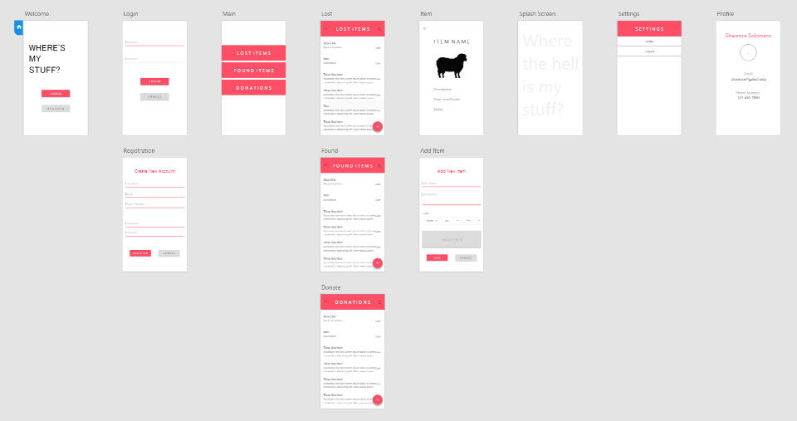

Figure I. UI Prototypes for Group 18 Where’s My Stuff app

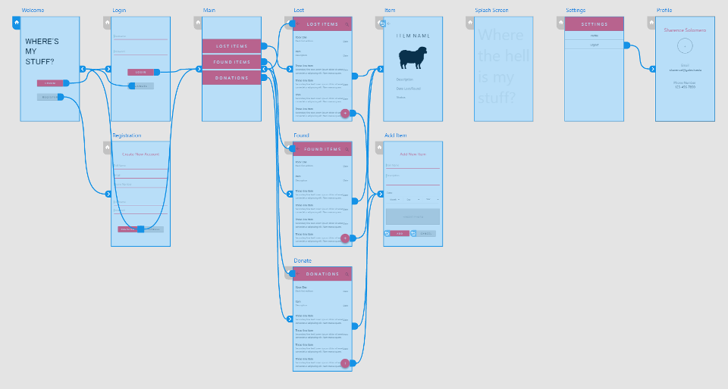

Figure II. Flow Diagram for Group 18 Where’s My Stuff app

**Note:** Visualize the actual flow of the application at: <https://xd.adobe.com/view/4e4948c8-54a8-4763-9cb7-f0daa8094228/>

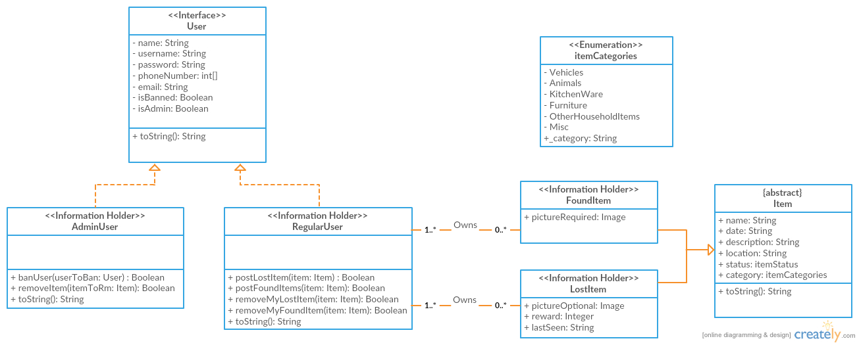

Figure III. UML Class Diagram for Group 18 Where’s My Stuff app

**Note:** Some private variables were included even if not necessary for completeness. However, most of these classes have getters and setters that were left out as instructed.